Logo Leisurewear 0114 251 1171
www.logoleisurewear.com
team@logoleisurewear.com
School Uniform
Order form
St Mary’s High Green
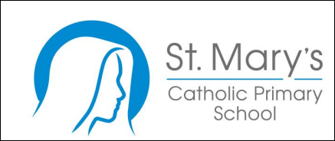
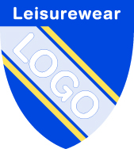 Size guidance

Size | 3/4 | 5/6 | 7/8 | 9/10 | 11/12 | 13
Chest  (Inches) | 24 | 26/28 | 30 | 32 | 34 | 35/36
Note: Ask for try on for size if unsure, fleece, coat and embroidered items sizes 13/14/15 are not exchangeable for size swap
ITEM | COLOUR |  | SIZE | QUANTITY | PRICE EACH |  | TOTAL PRICE
Sweatshirt + logo  Woodbank | Royal blue |  |  |  | £10.50
Sweat Cardigan + logo | Royal blue |  |  |  | £12.95
Polo Shirt + logo | White |  |  |  | £8.25
Plain shorts | Black |  |  |  | £4.50
Plain House PE Polo  Red,  Royal blue  Bottle green  Sun yellow |  |  |  |  | £4.50
Plain joggers | Black |  |  |  | £8.75
Book bag + logo | Royal blue |  |  |  | £6.50
NAME EMBROIDERY | white |  | N/A | *STATE NAME and ITEM below | £5.00
Knitted hat + logo | Royal blue |  | N/A |  | £5.25
Iron on name tapes |  |  | 100 |  | £7.50
Sew on name tapes |  |  | 72 |  | £7.00
ORDER TOTAL £
Please note minimum chq/card transaction of £10.00
Name
Name tapes: print clearly
School
Teacher/Class |  |  |  |  |  | Contact phone number:
*Name EMBROIDERY |  |  |  |  |  | STATE Item/s to have the name applied
We offer payment plans please ask us about how to set this up
Payment Options

Customers paying by card: please order online at logoleisurewear.com

Cash: Please enclose correct value and place in sealed envelope

Please complete the order form and drop in or post to
Orders
Logo Leisurewear Limited
5 Longacre close
Sheffield S20 3FR

